End to End ML Project with MLFlow/DVC

**Setup**

1. Create Template for project:
   1. E:\Data_Science\MLOps-Exp>**pip install cookiecutter**

Create a template : **cookiecutter -c v1** [**https://github.com/drivendata/cookiecutter-data-science**](https://github.com/drivendata/cookiecutter-data-science)

Add:

Project name : mlops-project

Repo name

Author name

Open source licence-3 #for no licence

Skip E3 and AWS

Add python-3 as interpreter

**Now move into cd mlops-project project and open VSCode**

**Note: we get all the files and folder as a template as a project by cookiecutter (delete some of the __init__ files from folders due to we will create ourself)**

**Under SRC folder:**

Remove __init__ and .py files we will write again----**(don’t delete __init__ file from SRC folder for SRC)**

1. **Crete a virtual env**

**Python –m venv myenv**

**Set this before activation**

**Set-ExecutionPolicy -Scope Process -ExecutionPolicy Bypass**

**✅ Why is it used for virtual environments or setup scripts?**

Many Python or ML projects (especially those using cookiecutter, venv, conda, etc.) may use:

* PowerShell scripts (.ps1)
* Virtual environment activation scripts (Activate.ps1)

Windows PowerShell might **block script execution** by default with errors like:

1. **We will set git for repo**

git init

add myenv into .gitignore (so that git not add this into gitfoler)

git add .

git commit –m “cookiecutter template”

-🡪 this is how we will add temp online into git

Lets move to github account-------------create a new repo to store this info into git

Once create repo foler on git appy to **set remote access**

E:\Data_Science\MLOps-Exp\mlops-project> **git remote add origin** [**https://github.com/LakhanGitHub/MLOps_Project.git**](https://github.com/LakhanGitHub/MLOps_Project.git)

**Upload data from local to git**

E:\Data_Science\MLOps-Exp\mlops-project> **git push origin master**

1. **Set Dagshub for MLFlow**

**MLflow tracking remote**

https://dagshub.com/LakhanGitHub/MLOps_Project.mlflow

**tracking code**

import dagshub

dagshub.init(repo_owner='LakhanGitHub', repo_name='MLOps_Project', mlflow=True)

import mlflow

with mlflow.start_run():

mlflow.log_param('parameter name', 'value')

mlflow.log_metric('metric name', 1)

MLFlowo URL: [MLflow](https://dagshub.com/LakhanGitHub/MLOps_Project.mlflow/)

* + Install dependencies
  + Pip install dagshub
  + Pip intall mlflow, seaborn, numpy ect…….xgboost

Check dagshub working properly, lets try write a file into **notebooks foder in VSCode**

**Dagshub_test.py**

import mlflow

import dagshub

mlflow.set_tracking_uri('https://dagshub.com/LakhanGitHub/MLOps_Project.mlflow/')

dagshub.init(repo_owner='LakhanGitHub', repo_name='MLOps_Project', mlflow=True)

with mlflow.start_run():

  mlflow.log_param('parameter name', 'value')

  mlflow.log_metric('metric name', 1)

E:\Data_Science\MLOps-Exp\mlops-project> **python \notebooks\dagsbub_test.py**

**Experiments**

Here we will do some experiments and track in mlflow

Exp1: Random forest classifier: random test to track matrix and pramameters **exp1.py**

from sklearn.model_selection import train_test_split

from sklearn.metrics import accuracy_score, confusion_matrix, f1_score, recall_score, precision_score

import matplotlib.pyplot as plt

import seaborn as sns

import pandas as pd

import numpy as np

import mlflow.sklearn

import mlflow

import dagshub

#initilize dagshub and set mlflow for experiment tracking

dagshub.init(repo_owner='LakhanGitHub', repo_name='MLOps_Project', mlflow=True)

mlflow.set_experiment('Experiment1')

mlflow.set_tracking_uri('https://dagshub.com/LakhanGitHub/MLOps_Project.mlflow/')

#load data

data = pd.read_csv(r'E:\Data_Science\MLOps-Exp\water_potability.csv')

#tain test split

train_data, test_data = train_test_split(data, test_size=0.20, random_state=42)

#impute missing values

def fill_missing_value(df):

    for col in df.columns:

        if df[col].isnull().any():

            mean_value = df[col].median()

            df[col].fillna(mean_value, inplace=True)

    return df

train_processed_data = fill_missing_value(train_data)

test_processed_data = fill_missing_value(test_data)

#randomfortestclassifier

from sklearn.ensemble import RandomForestClassifier

import pickle

#seprate train(X) and test(y)

X_train = train_processed_data.drop(columns=['Potability'], axis=1)

y_train = train_processed_data['Potability']

X_test = test_processed_data.iloc[:,0:-1].values

y_test = test_processed_data.iloc[:,-1]

n_enstimators = 100

with mlflow.start_run():

    clf = RandomForestClassifier(n_estimators=n_enstimators)

    clf.fit(X_train,y_train)

    #save file into pikle

    pickle.dump(clf, open('model.pkl','wb'))

    y_pred = clf.predict(X_test)

    acc = accuracy_score(y_test, y_pred)

    pre = precision_score(y_test, y_pred)

    recall = recall_score(y_test, y_pred)

    f1_score = f1_score(y_test, y_pred)

    #log the metircs and parameters

    mlflow.log_metric('accurace',acc)

    mlflow.log_metric('precision',pre)

    mlflow.log_metric('recall',recall)

    mlflow.log_metric('f1_score',f1_score)

    mlflow.log_param('n_estimators', n_enstimators)

    cm = confusion_matrix(y_test, y_pred)

    plt.figure(figsize=(5,5))

    sns.heatmap(cm, annot=True)

    plt.xlabel('Predicted')

    plt.ylabel('Actual')

    plt.title('Confution Metrics')

    plt.savefig('confution_matrix.png')

    #log artifact

    mlflow.log_artifact('confution_matrix.png')

    mlflow.log_artifact(__file__)

    #log mode

    mlflow.sklearn.log_model(clf,'RandomForestClassifier')

    #set tags addition metadata

    mlflow.set_tag('Author', 'Lakhan')

    mlflow.set_tag('model', 'Random Forest')

    #print accuracy

    print('Accuracy', acc)

    print('Precision', pre)

    print('Recall', recall)

    print('f1_score', f1_score)

**##adding Second Experiment-------**

**With random model with filling missing value as median()**

models = {

    'Logistic Regression': LogisticRegression(),

    'Random Forest':RandomForestClassifier,

    'SVM': SVC(),

    'Decision Tree':DecisionTreeClassifier(),

    'K-Nearst Neighbors':KNeighborsClassifier(),

    'XGboost':XGBClassifier()

}

**##Third Experimane filling missing values with mean()**

**With random model with filling missing value as median**

models = {

    'Logistic Regression': LogisticRegression(),

    'Random Forest':RandomForestClassifier,

    'SVM': SVC(),

    'Decision Tree':DecisionTreeClassifier(),

    'K-Nearst Neighbors':KNeighborsClassifier(),

    'XGboost':XGBClassifier()

}

**#adding 4th exp**

**Whrere I am using randomd forest having max accury**

from sklearn.model_selection import train_test_split, RandomizedSearchCV

from sklearn.metrics import accuracy_score

import pandas as pd

import numpy as np

from sklearn.ensemble import RandomForestClassifier

import mlflow.sklearn

import mlflow

import dagshub

import os

# Initialize dagshub and set mlflow for experiment tracking

dagshub.init(repo_owner='LakhanGitHub', repo_name='MLOps_Project', mlflow=True)

mlflow.set_experiment('Experiment4_2')

mlflow.set_tracking_uri('https://dagshub.com/LakhanGitHub/MLOps_Project.mlflow/')

# Load dataset

data_path = r'E:\Data_Science\MLOps-Exp\water_potability.csv'

data = pd.read_csv(data_path)

# Train-test split

train_data, test_data = train_test_split(data, test_size=0.20, random_state=42)

# Function to impute missing values with mean

def fill_missing_value(df):

    for col in df.columns:

        if df[col].isnull().any():

            mean_value = df[col].mean()

            df[col].fillna(mean_value, inplace=True)

    return df

train_processed_data = fill_missing_value(train_data)

test_processed_data = fill_missing_value(test_data)

# Separate features and target

X_train = train_processed_data.drop(columns=['Potability'], axis=1)

y_train = train_processed_data['Potability']

X_test = test_processed_data.drop(columns=['Potability'], axis=1)

y_test = test_processed_data['Potability']

# Define model and parameter grid

rf = RandomForestClassifier(random_state=42)

param_dict = {

    'n_estimators': [100, 200, 300, 400, 500],

    'max_depth': [4, 5, 6, 10]

}

# Setup RandomizedSearchCV

random_search = RandomizedSearchCV(rf, param_distributions=param_dict, cv=5, n_iter=50, n_jobs=-1, verbose=False)

with mlflow.start_run(run_name='Random Forest tuning') as parent_run:

    random_search.fit(X_train, y_train)  # Fit the search

    for i in range(len(random_search.cv_results_['params'])):

        with mlflow.start_run(run_name=f"combination_{i+1}", nested=True) as child_run:

            # Get parameter combination

            params = random_search.cv_results_['params'][i]

            # Train model with current params

            model = RandomForestClassifier(random_state=42, **params)

            model.fit(X_train, y_train)

            # Predict and evaluate

            y_pred = model.predict(X_test)

            acc = accuracy_score(y_test, y_pred)

            # Log parameters and metrics

            mlflow.log_params(params)

            mlflow.log_metric("mean_cv_score", random_search.cv_results_['mean_test_score'][i])

            mlflow.log_metric("test_accuracy", acc)

            # Log the trained model

            mlflow.sklearn.log_model(model, artifact_path="model")

            # Log datasets (train and test) as artifacts

            train_csv_path = "train_data.csv"

            test_csv_path = "test_data.csv"

            train_processed_data.to_csv(train_csv_path, index=False)

            test_processed_data.to_csv(test_csv_path, index=False)

            mlflow.log_artifact(train_csv_path, artifact_path="datasets")

            mlflow.log_artifact(test_csv_path, artifact_path="datasets")

            # Clean up temporary files

            os.remove(train_csv_path)

            os.remove(test_csv_path)

    # Log the best overall model

    mlflow.log_params(random_search.best_params_)

    mlflow.sklearn.log_model(random_search.best_estimator_, artifact_path="best_model")

    print("Best parameters found:", random_search.best_params_)

    print("Training, evaluation, model, and dataset logging completed successfully.")

**#Built DVC pipeline**

* + **for data versioning we add a remote file into temp folter**
  + **>dvc init**

**>dvc remote add –d myremote C:\Windows\Temp**

**Name: C:\Windows\Temp\dvc**

**Dvc is a lolder under temp**

**Loc: C:\Windows\Temp**

**(this is temp foler for temp storate on production we upload data on AWS etc)**

**##Create oure best final model and log into mlflow**

import pandas as pd

import numpy as np

import pickle

import json

from mlflow.models.signature import infer_signature

from sklearn.metrics import accuracy_score, precision_score, recall_score, f1_score

import mlflow.sklearn

import mlflow

import dagshub

import os

# Initialize dagshub and set mlflow for experiment tracking

dagshub.init(repo_owner='LakhanGitHub', repo_name='MLOps_Project', mlflow=True)

mlflow.set_experiment('Best_model')

mlflow.set_tracking_uri('https://dagshub.com/LakhanGitHub/MLOps_Project.mlflow/')

test_data = pd.read_csv('./data/processed/test_processed.csv')

X_test = test_data.iloc[:,0:-1].values

y_test = test_data.iloc[:,-1].values

model = pickle.load(open('model.pkl','rb'))

y_pred= model.predict(X_test)

with mlflow.start_run(run_name="DVC Model") as run:

    acc = accuracy_score(y_test, y_pred)

    pre = precision_score(y_test, y_pred)

    recall = recall_score(y_test, y_pred)

    f1 = f1_score(y_test, y_pred)

    # Log parameters and metrics

    mlflow.log_params({

    'n_estimators': 400,

    'max_depth': 5

    })

    mlflow.log_metric("accuracy", acc)

    mlflow.log_metric("precision", pre)

    mlflow.log_metric("recall", recall)

    mlflow.log_metric("f1_score", f1)

    mlflow.log_artifact(__file__)

   # Log the trained model

    signature_ = infer_signature(X_test, model.predict(X_test))

    mlflow.sklearn.log_model(model, 'Best Model', signature= signature_)

    #save run id and model info into JSON file:

    run_info = {'run_id': run.info.run_id, 'model_name':'Best_Model'}

    report_path = 'reports/run_info.json'

    with open(report_path, 'w') as file:

        json.dump(run_info,file,indent=4)

    metrics_dict = {

        'acc':acc,

        'precision':pre,

        'recall':recall,

        'f1 score': f1

    }

    with open('metrics.json','w') as file:

        json.dump(metrics_dict, file, indent=4)

**Capture final model run id from Dagshub………………**

with mlflow.start_run(run_name="DVC Model") as run: #add this as run here

**from below code by above code snipit**

#save run id and model info into JSON file:

    run_info = {'run_id': run.info.run_id, 'model_name':'Best_Model'}

    report_path = 'reports/run_info.json'

    with open(report_path, 'w') as file:

        json.dump(run_info,file,indent=4)

**By this be store model as version, this help to maintain model version at each run similar to git and dvc version control**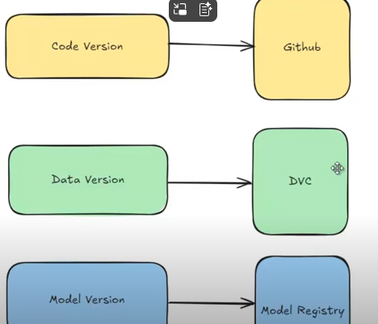

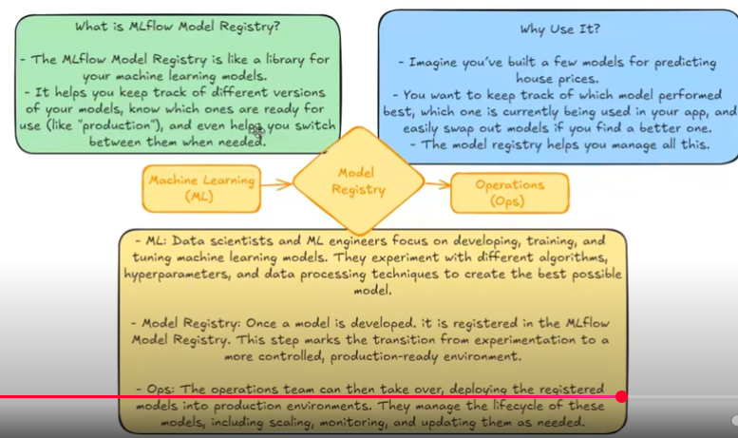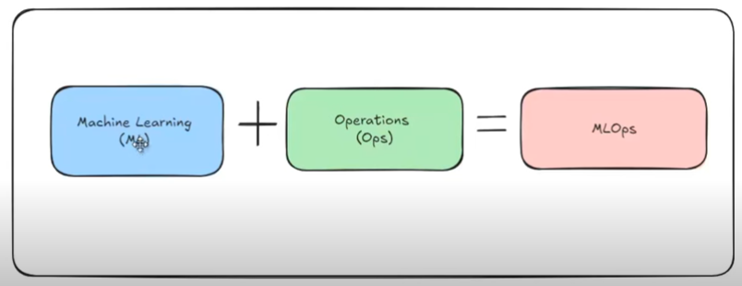

**Model registry is the mid point of ml and ops**

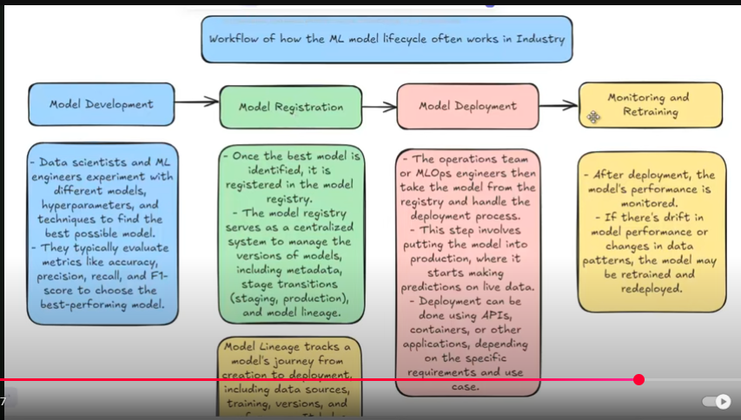

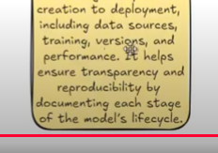

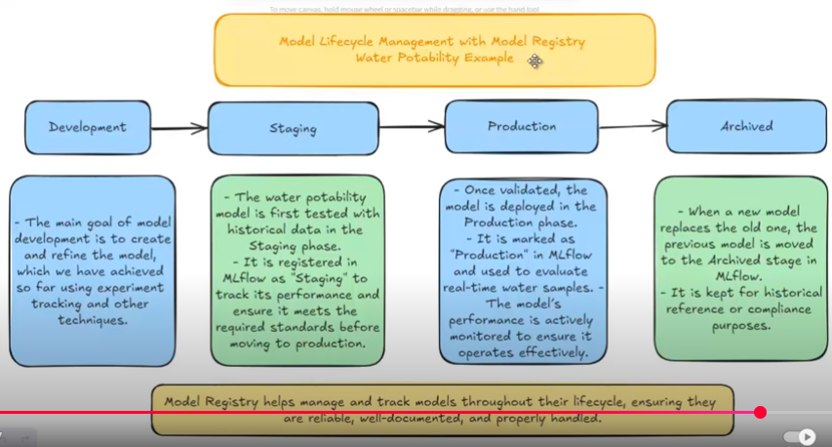

**##now regisger model with staging**

**Create model_reg.py under model foler**

import json

import mlflow

import dagshub

from mlflow import MlflowClient

# Initialize dagshub and set mlflow for experiment tracking

dagshub.init(repo_owner='LakhanGitHub', repo_name='MLOps_Project', mlflow=True)

mlflow.set_experiment('Final_Model')

mlflow.set_tracking_uri('https://dagshub.com/LakhanGitHub/MLOps_Project.mlflow/')

#load the run id and model name from saved json file

report_path = 'reports/run_info.json'

with open(report_path, 'r') as file:

    run_info = json.load(file)

run_id = run_info['run_id']

model_name = run_info['model_name']

#create mlflow client

client = MlflowClient()

#create the model uri

model_uri = f"runs:/{run_id}/artifacts/{model_name}"

#register model

reg = mlflow.register_model(model_uri,model_name)

#get the model version

model_version = reg.version

#transition the model into staging

new_stage = 'Staging'

client.transition_model_version_stage(

    name = model_name,

    version=model_version,

    stage = new_stage,

    archive_existing_versions=True

)

print(f"model {model_name} versioni {model_version} transitioned to {new_stage} stage.")

**here we have added stage as verion-1**

**now add this flow into dvc pipeline so that this staging will change automaticly once we have another version**

under **dvc.yaml** add below code to the bottom

 model_registration:

    cmd: python src/model/model_reg.py

    deps:

    - reports/run_info.json

    - src/model/model_reg.py

This will register our model with pipeline

We can see this will add new version as we run pipeline automaticly

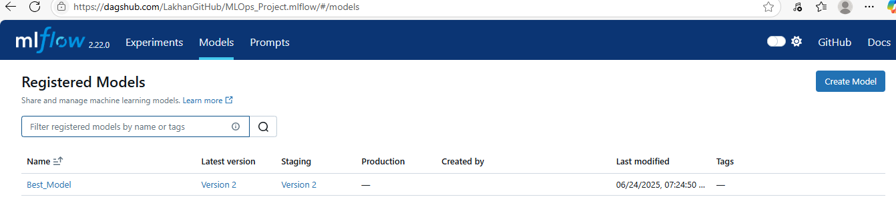

#Downlaod production version from mlflow and can do prediction

Create a file prediction.py outside near dvc.ymal

import json

import mlflow

import dagshub

from mlflow import MlflowClient

import pandas as pd

# Initialize dagshub and set mlflow for experiment tracking

dagshub.init(repo_owner='LakhanGitHub', repo_name='MLOps_Project', mlflow=True)

mlflow.set_tracking_uri('https://dagshub.com/LakhanGitHub/MLOps_Project.mlflow/')

#load the run id and model name from saved json file

model_name = 'Best_Model' #registered model

try:

    client = mlflow.tracking.MlflowClient()

    versions = client.get_latest_versions(model_name, stages=['Staging'])

    if versions:

        latest_version = versions[0].version

        run_id = versions[0].run_id #fatching the run id and latest version

        print(f'latest verion in staging :{latest_version}, run id {run_id}')

        logged_model = f'runs:/{run_id}/Best Model'  # artifact name "Best Model" 4f9f80232/artifacts/Best Model/model.pkl

        print(f'logged model :{logged_model}')

        #load the model using the loggged_model variable

        loaded_model = mlflow.pyfunc.load_model(logged_model)

        print(f'model loaded from {logged_model}')

        #input data for prediction

        data  = pd.DataFrame({

            'ph':[3.71608],

            'Hardness':[204.89045],

            'Solids':[20791.31890],

            'Chloramines':[7.3000],

            'Sulfate':[381.5164],

            'Conductivity':[564.3086],

            'Organic_carbon':[10.3700],

            'Trihalomethanes':[86.99],

            'Turbidity':[2.9634]

        })

        prediction = loaded_model.predict(data)

        print(f'prediction {prediction}')

    else:

        print('no model exist in production stage')

except Exception as e:

    print(f'error fetching model :{e}')

this will doanload staging or production model like that and to prediction

here predictionis “0” water not portable:

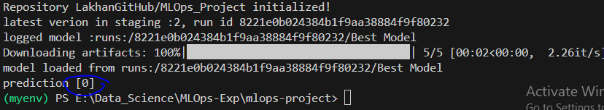

By this production model we can create flask or streamlit App to build frontend and desing app.

**Stramlist app top of production staging:**import streamlit as st

import pandas as pd

import mlflow

from mlflow.tracking import MlflowClient

# Set MLflow tracking

mlflow.set_tracking_uri('https://dagshub.com/LakhanGitHub/MLOps_Project.mlflow/')

model_name = 'Best_Model'

# Cache model loading to avoid re-downloading on every prediction

@st.cache_resource

def load_model_from_staging():

    try:

        client = MlflowClient()

        versions = client.get_latest_versions(model_name, stages=["Staging"])

        if versions:

            run_id = versions[0].run_id

            logged_model = f"runs:/{run_id}/Best Model"  # Adjust artifact name if needed

            model = mlflow.pyfunc.load_model(logged_model)

            return model

        else:

            st.error("⚠️ No model found in Staging stage.")

            return None

    except Exception as e:

        st.error(f"Error loading model:\n{e}")

        return None

# Load model at app start

loaded_model = load_model_from_staging()

# Streamlit UI

st.title("💧 Water Potability Prediction App")

st.write("Provide water quality parameters below to predict if the water is **safe to drink**.")

# Input Form

with st.form("input_form"):

    col1, col2, col3 = st.columns(3)

    with col1:

        ph = st.number_input("pH Value", min_value=0.0, max_value=14.0, value=7.0, step=0.1)

        hardness = st.number_input("Hardness", min_value=0.0, value=150.0)

        solids = st.number_input("Solids (ppm)", min_value=0.0, value=10000.0)

    with col2:

        chloramines = st.number_input("Chloramines (ppm)", min_value=0.0, value=7.0)

        sulfate = st.number_input("Sulfate (ppm)", min_value=0.0, value=350.0)

        conductivity = st.number_input("Conductivity (µS/cm)", min_value=0.0, value=500.0)

    with col3:

        organic_carbon = st.number_input("Organic Carbon (ppm)", min_value=0.0, value=10.0)

        trihalomethanes = st.number_input("Trihalomethanes (µg/L)", min_value=0.0, value=80.0)

        turbidity = st.number_input("Turbidity (NTU)", min_value=0.0, value=3.0)

    submit = st.form_submit_button("Predict")

# Prediction Logic

if submit:

    if loaded_model is not None:

        input_data = pd.DataFrame({

            'ph': [ph],

            'Hardness': [hardness],

            'Solids': [solids],

            'Chloramines': [chloramines],

            'Sulfate': [sulfate],

            'Conductivity': [conductivity],

            'Organic_carbon': [organic_carbon],

            'Trihalomethanes': [trihalomethanes],

            'Turbidity': [turbidity]

        })

        try:

            prediction = loaded_model.predict(input_data)[0]

            if prediction == 1:

                st.success("✅ The water is **Safe to Drink**.")

            else:

                st.error("The water is **Not Safe to Drink**.")

        except Exception as e:

            st.error(f"Error during prediction:\n{e}")